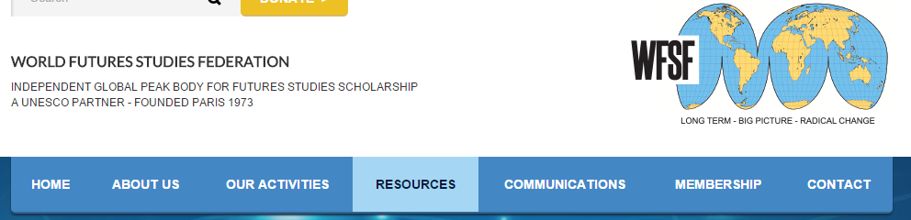

LEALA Pedagogical Resources
World Futures Studies Federation (WFSF)

Founded in Paris in 1973, the nonprofit WFSF is a UNESCO and UN consultative partner and global NGO. Members include academics, researchers, practitioners, students and futures-focused institutions.
Providing a platform for collaboration, WFSF offers opportunity for people to design alternative futures that incorporate long-term, top-level thinking and sweeping change.

LEALA Pedagogical Resources exemplify their mission by supplying a repository of pedagogical resources, including articles, books, course materials, images, videos, PowerPoint slides and games.

Educational Futures Overviews
The most up-to-date bibliographies from several sources are available. Also included are two "Educational Futures" reports: Futures in Education (2004) and International Survey of University Futures Courses (2006).

Course Material
Over twenty articles are available for teachers to use, most in English. Examples include: Causal Layered Analysis Deepening the Future (Sohail Inayatullah 2005) Foresight Maturity Model (Terry Grim 2009) Futures Studies Theories and Methods (Sohail Inayatullah 2013) and Holistic Education and Futures Visions (Jennifer M. Gidley 2002).

Over twenty course outlines and related class materials are accessible, including: The Art of Forecasting and International Futures (Barry Hughes); Futures Studies (Christopher Jones), Learning Outcomes, Certificate in Strategic Foresight Course Products, The Future; Anticipating the Future; Baseline Analysis; Change; Change Management; Planning; Visioning; and Leadership (Peter Bishop, Andy Hines, University of Houston); Peace Education: Understanding and Negotiating Conflicts In Our Schools, Families and Communities and Schools That Learn: Creating Futures That Matter (Ivana Milosevic), Reform versus Strategy: Making Choices at the End of the Administrative Era (Riel Miller); and Education and Future (Éva Hideg and Erzsébet Nováky, Corvinus, University of Budapest).

Futures Books and Reports
Over a dozen full text, open source books are available, including: Democracy and Futures (Mika Mannermaa, Jim Dator, and Paula Tiihonenv, Eds.) and How Open is the Future? (Marleen Wynants and Jan Cornelis (Eds.)

Over twenty reports from the UN and other international organizations are available, including: Foresight in Governments - Practices and Trends around the World (Iana Dreyer and Gerald Stang) and The World in 2025 (European Commission).

Videos and Multi-Media Presentations
Over twenty videos are available through two World Futures Learning Lab (LEALA).channels. Titles include: Keynote Speech at the 21st WFSF World Conference, Johan Galtung; A “New Wave” Opening Speech at the 21st WFSF World Conference, Adrian Curaj; Enlarging the Field of Futures Studies. The Emergent Discipline of Anticipation, Riel Miller; Where to Tomorrow for Futures Studies, Jennifer M. Gidley; Foresight and Strategic Transformation, Sohail Inayatullah; Futures Education Speech at the 21st WFSF World Conference, Peter Bishop; Why Futures Studies? An Interview with Jim Dator; Long Conversation; Pete Worden Announces 100-Year Starship; and Design Futures, Stuart Candy.

Texts Accompanying Video Resources
Five presentation slide texts are available: Evolution of Consciousness and Paradigm Change and Where to Tomorrow for Futures Studies by Jennifer M. Gidley and “Ignite Your Future” STEM and the World Career Discussion, (three lesson plans).

PowerPoint Presentations
Three PowerPoint presentations are currently available, all from Jennifer M. Gidley: Planetary Futures for Higher Education: From Neoliberal Commodification to Global Justice and Cultural Potential; Shifting Metaphors for Re-Imagining Post-industrial City Futures; and Megatrends of the Mind: Impact on Today’s Young People?

Pedagogical Games & Interactive Web-Resources

Available is Gaming for a Higher Cause, an article by Tom Huston and links to eight websites:
- CYBERHERO LEAGUE is an interactive mobile gaming adventure where players learn about global challenges while training to become real world heroes.
- Personal Futures Network is a website and workbook from Verne Wheelwright that helps people learn about and plan for their personal futures.
- 2020 Energy is a serious and fun game about energy efficiency, renewable energy and sustainable development especially aimed at reaching a 14-18 year old demographic.
- "Ignite Your Future" is a five minute long career guidance video and supporting lesson plans for pupils, especially secondary school students.
- Xplore Malaria examines how to achieve a malaria-free world using games, videos and virtual experiments. The ethical, legal and social implications of malaria research are revealed through the process.
- La Maison positive is a French film about the construction of a positive (zero) energy home by vocational college students that illustrates sustainable development as well as multidisciplinary behavior in education.
- Our World is a web magazine hosting video briefs, articles, debates, photo essays and public events. from the United Nations University (UNU). Subject categories are Science and Technology, Development and Society, Peace and Security, Humanitarian Affairs and Human Rights. Knowing the changes taking place in these categories stimulates transitional plans for futures, e.g., a low carbon future society.
- The Wisdom Years is an e-case study and video documentary exploring the issue of ageing in Japan. How science can prolong human life and how health and activity are tied to social ties are researched. Incorporating social determinants of health in policy-oriented interventions is advocated for governments. Ageing is an understandable and personally-relevant futures topic: the future is where all people will spend their remaining time.

